

Dreams Adult Day Program is a community-based day program serving individuals in the Denver Metro Area. We offer small group to staff ratios, dedicating more individualized time and attention to specific needs. Our focus is finding creative ways to access the community while having fun and working on individualized goals and skills.
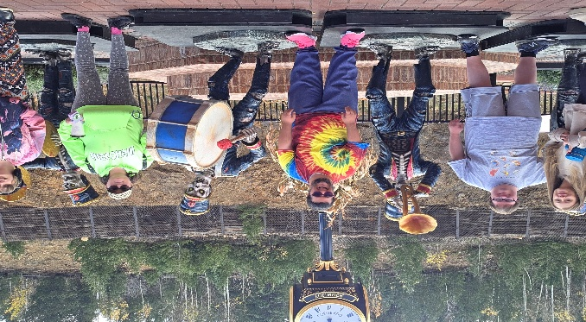

Some examples of the activities we currently offer include bowling, swimming, visits to libraries, karaoke, nature walks, volunteering at animal shelters, The Botanical Gardens, The Denver Zoo, The Nature and Science Museum, Molly Brown house, Wings over the Rockies, Art Museum, Eliches water park, Fun day at the reservoir with BBQ and games, Night to Shine Prom, Dance classes, Coffee and Paint Class, Arts and Crafts and many more!
Contact Brittany to set up a meet and greet or trial day @ 720-327-7598 or email brittanytorres87@outlook.com
